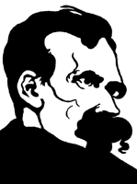

Neighbor Love

My brethren, I advise you not to neighbor-love- I advise you to
furthest love!

Truth

What then is truth? A mobile army of metaphors, metonyms, and anthropomorphisms: in short, a sum of human relations which have been poetically and rhetorically intensified, transferred, and embellished, and which, after long usage, seem to a people to be fixed, canonical, and binding. Truths are illusions which we have forgotten are illusions—they are metaphors that have become worn out and have been drained of sensuous force, coins which have lost their embossing and are now considered as metal and no longer as coins

Becoming Yourself

Human beings who do not want to belong to the mass need only to stop, and not be comfortable; follow their conscience, which cries out: "Be yourself! All you are now doing, thinking, desiring, is not you yourself."...

Ends

Not every end is the goal. The end of a melody is not its goal; and yet: if a melody has not reached its end, it has not reached its goal.
During the journey we commonly forget its goal. Almost every profession is chosen as a means to an end but continued as an end in itself. Forgetting our objectives is the most frequent act of stupidity

God

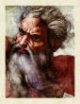
God is dead. God remains dead. And we have killed him

Do not by any means know atheism as a result; even less as an event: it is a matter of course with me, from instinct. I am too inquisitive, too questionable, too exuberant to stand for any gross answer. God is a gross answer, an indelicacy against us thinkers—at bottom merely a gross prohibition for us: you shall not think

Living Dangerously

For believe me: the secret for harvesting from existence the greatest fruitfulness and the greatest enjoyment is—to live dangerously! Build your cities on the slopes of Vesuvius

Science


.A "scientific" interpretation of the world, as you understand it, might therefore still be one of the most stupid of all possible interpretations of the world, meaning that it would be one of the poorest in meaning...an essentially mechanistic world would be an essentially meaningless world...

Overman
I teach you the overman.
Man is something that shall be overcome. What have you done to overcome him...
The overman is the meaning of the earth...Where is the lightning to lick you with its tongue? Where is the frenzy with which you should be inoculated? Behold,
I teach you the overman: he is this lightning, he is this frenzy

Love
Of all that is written I love only what a man has written with his blood.
Write with blood, and you will experience that blood is spirit..
.True, we love life, not because we are used to living but because we are used to loving. There is always some madness in love. But there is also always some reason in madness..
.I would believe only in a god who could dance.

Enemies

You may have only enemies whom you can hate, not enemies you despise.

You must be proud of your enemy: then the successes of your enemy are your successes too

The Earth

Remain faithful to the earth, my brothers, with the power of your virtue. Let your gift-giving love and your knowledge serve the meaning of the earth. Thus I beg and beseech you. Do not let them fly away from earthly things and beat with their wings against eternal walls. Alas, there has always been so much virtue that has flown away. Lead back to the earth the virtue that flew away, as I do—back to the body, back to life, that it may give the earth a meaning, a human meaning.

Believers
One repays a teacher badly if one always remains nothing but a pupil. And why do you not want to pluck at my wreath?..
You say you believe in Zarathustra? But what matters Zarathustra? You are my believers—but what matter all believers? You had not yet sought yourselves: and you found me.
Thus do all believers; therefore all faith amounts to so little.
Now I bid you lose me and find yourselves; and only when you have all denied me will I return to you

Beggars
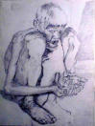
Beggars should be abolished entirely! Verily it is annoying to give to them, and it is annoying not to give to them

Weaklings

Verily, I have often laughed at the weaklings who thought themselves good because they had no claws.

The Way

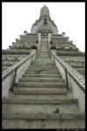
"This is my way; where is yours?"—thus I answered those who asked me "the way." For the way—that does not exist.

Good and Evil

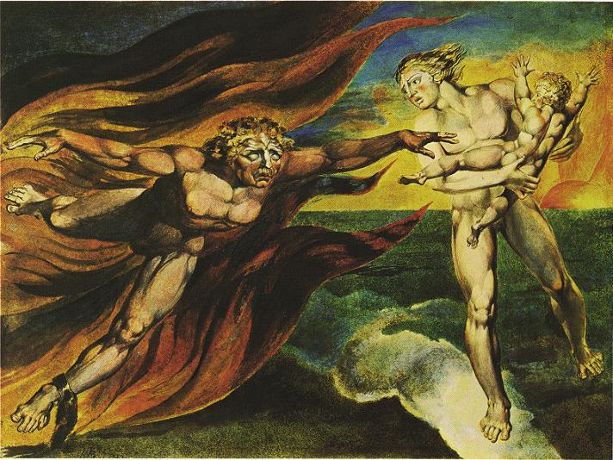
What is good and evil no one knows yet, unless it be he who creates. He, however, creates man's goal and gives the earth its meaning and its future. That anything at all is good and evil—that is his creation

Creators
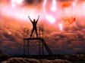
For creators are hard...This new tablet, O my brothers, I place over you: become hard!

The Indignant

No one lies as much as the indignant do.

Masks
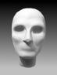

Every profound spirit needs a mask: even more, around every profound spirit a mask is growing continually, owing to the constantly false, namely shallow, interpretation of every word, every step, every sign of life he gives

Chaos

I say unto you: One must still have chaos in oneself to give birth to a dancing star

Morality
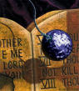
Morality is herd instinct in the individual
There are no moral phenomenon at all, but only a moral interpretation of phenomena

Faith

To accept a faith just because it is customary, means to be dishonest, to be cowardly, to be lazy. And do dishonesty, cowardice, and laziness then appear as the presupposition of morality

The Despisers of Life:

Despisers of life are they, decaying ones and poisoned ones
themselves, of whom the earth is weary: so away with them!

Once blasphemy against God was the greatest blasphemy; but God died,
and therewith also those blasphemers. To blaspheme the earth is now
the dreadfulest sin, and to rate the heart of the unknowable higher
than the meaning of the earth!

The Old Man in the Wilderness:

Now I love God: men, I do not love. Man is a thing too imperfect for
me. Love to man would be fatal to me."

When Zarathustra was alone, however, he said to his heart: "Could it
be possible! This old saint in the forest hath not yet heard of it,
that God is dead!"

The Hour of Loathing
What is the greatest thing ye can experience? It is the hour of great contempt. The hour in which even your happiness becomes loathsome unto you, and so also your reason and virtue. The hour when ye say: "What good is my happiness! It is poverty and pollution and wretched self-complacency. But my happiness should justify existence itself!" The hour when ye say: "What good is my reason! Doth it long for knowledge as the lion for his food? It is poverty and pollution and wretched self-complacency!" The hour when ye say: "What good is my virtue! As yet it hath not made me passionate. How weary I am of my good and my bad! It is all poverty and pollution and wretched self-complacency!" The hour when ye say: "What good is my justice! I do not see that I am fervour and fuel. The just, however, are fervour and fuel!" The hour when we say: "What good is my pity! Is not pity the cross on which he is nailed who loveth man? But my pity is not a crucifixion."

The Tightrope Walker
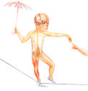

Man is a rope stretched between the animal and the Superman- a rope over an abyss.
A dangerous crossing, a dangerous wayfaring, a dangerous looking-back, a dangerous trembling and halting. What is great in man is that he is a bridge and not a goal: what is lovable in man is that he is an over-going and a down-going. I love those that know not how to live except as down-goers, for they are the over-goers.

Who Zarathustra Loves
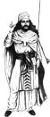
I love him who is of a free spirit and a free heart: thus is his
head only the bowels of his heart; his heart, however, causeth his
down-going.

The Last Man

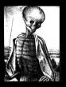

Alas! There cometh the time when man will no longer give birth to any star. Alas! There cometh the time of the most despicable man, who can no longer despise himself. Lo! I show you the last man

Death
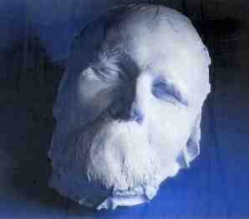
To die proudly when it is no longer possible to love proudly. Death freely chosen, death at the right time, brightly and cheerfully accomplished amid children and witnesses: then a real farewell is still possible, as the one who is taking leave is still there

Death of the Tightrope Walker
"What art thou doing there?" said he at last, "I knew long ago that the devil would trip me up. Now he draggeth me to hell: wilt thou prevent him?"
"On mine honour, my friend," answered Zarathustra, "there is nothing of all that whereof thou speakest: there is no devil and no hell. Thy soul will be dead even sooner than thy body; fear, therefore, nothing any more!"
The man looked up distrustfully. "If thou speakest the truth," said he, "I lose nothing when I lose my life. I am not much more than an animal which hath been taught to dance by blows and scanty fare."
"Not at all," said Zarathustra, "thou hast made danger thy calling; therein there is nothing contemptible. Now thou perishest by thy calling: therefore will I bury thee with mine own hands."

The Good and the Just:

Behold the good and just! Whom do they hate most? Him who breaketh up their tables of values, the breaker, the lawbreaker:- he, who is the creator.

The Metamorphoses of the Spirit:

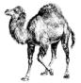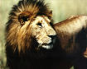

Three metamorphoses of the spirit have I designated to you: how
the spirit became a camel, the camel a lion, and the lion at last a
child.-

Celestial Things
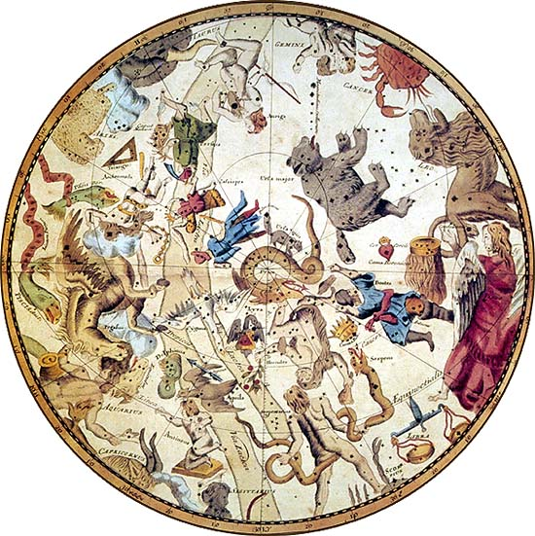

A new pride taught me mine ego, and that teach I unto men: no longer
to thrust one's head into the sand of celestial things, but to carry
it freely, a terrestrial head, which giveth meaning to the earth!

The Sick
The sick and perishing- it was they who despised the body and the
earth, and invented the heavenly world, and the redeeming blood-drops;
but even those sweet and sad poisons they borrowed from the body and the earth!
From their misery they sought escape, and the stars were too remote for them. Then they sighed: "O that there were heavenly paths by which to steal into another existence and into happiness!" Then they contrived for themselves their bypaths and bloody draughts! Beyond the sphere of their body and this earth they now fancied themselves transported, these ungrateful ones. But to what did they owe the convulsion and rapture of their transport? To their body and this earth.

The Despisers of the Body:

"Body am I, and soul"- so saith the child. And why should one not speak like children? But the awakened one, the knowing one, saith: "Body am I entirely, and nothing more; and soul is only the name of something in the body."

Virtues

MY BROTHER, when thou hast a virtue, and it is thine own virtue, thou hast it in common with no one.

And lo! Then hast thou its name in common with the people, and hast become one of the people and the herd with thy virtue! Better for thee to say: "Ineffable is it, and nameless, that which is pain and sweetness to my soul, and also the hunger of my bowels."

Let thy virtue be too high for the familiarity of names, and if thou must speak of it, be not ashamed to stammer about it.

The Pale Criminal
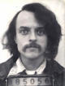

YE DO not mean to slay, ye judges and sacrificers, until the animal hath bowed its head? Lo! the pale criminal hath bowed his head: out of his eye speaketh the great contempt. An idea made this pale man pale. Adequate was he for his deed when he did it, but the idea of it, he could not endure when it was done.

Warriors
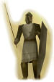

I know the hatred and envy of your hearts. Youre not great enough not to know of hatred and envy.

Then be great enough not to be ashamed of them!

And if youannot be saints of knowledge, then, I pray you, be at least its warriors.

They are the companions and forerunners of such saintship.

The State
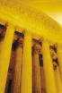
But the state lies in all languages of good and evil; and whatever it says it lies whatever it has been stolen. False is everything in it; with stolen teeth it bites, the biting one. False are even its bowels.

The Market-Place
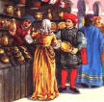

Where solitude ends, there begins the market-place; and where the market-place begins, there begins also the noise of the great actors, and the buzzing of the poison-flies. In the world even the best things are worthless without those who represent them: those representers, the people call great men.

Memory and Pride

"I have done that," says my memory, "I cannot have done that," says my pride, and remains inexorable. Eventually- memory yields.

Against an Enemy

How good bad music and bad reasons sound when one marches against an enemy

Facts

There are no facts; only interpretations.

Soaring
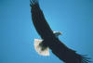

Never forget! The higher we soar the smaller we appear to those who cannot fly.

Man

Error has transformed animals into men; is truth perhaps capable of changing man back into an animal?

Freedom

What is the seal of attained freedom?
No longer being ashamed in front of oneself.

Sensual Love

Sensuality often hastens the growth of love so much that the roots remain weak and are easily torn up.

Talking About Oneself

Talking much about oneself can also be a means to conceal oneself.

Friend's Secrets

Few people will not expose the private affairs of their friends when at a loss for a subject of conversation.

Music
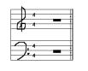

Without music, life would be a mistake.
Because of music the passions enjoy themselves.

Madness

I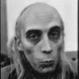
In individuals, madness is rare. But in groups, parties, nations, and ages, it is the rule

Women's Friendships

Women can enter into a friendship with a man perfectly well; but in order to maintain it, the aid of a little physical antipathy is perhaps required.

Stars
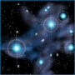

As long as you still experience the stars as something "above you," you lack the eye of knowledge

The Way to Equality

A few hours of mountain climbing turn a villain and a saint into two rather equal creatures. Exhaustion is the shortest way to equality and fraternity- and liberty is added eventually by sleep.

Becoming an Animal

Today the man of knowledge might well feel like God become animal.

Truth

Perhaps nobody yet has been truthful enough about what "truthfulness" is.
Truth will have no gods before it.- The belief in truth begins with the doubt of all truths in which one has previously believed.

The Monster
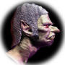

Whoever fights monsters should see to it that in the process he does not become a monster.

And when you look long into an abyss, the abyss also looks into you.

The Snake

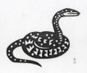

Shedding one's skin. The snake that cannot shed its skin perishes. So do the spirits who are prevented from changing their opinions; they cease to be spirit.

Opinions



The first opinion that occurs to us when we are suddenly asked about anything is not usually our own, but only the current opinion belonging to our caste, position, or family; our own opinions seldom float on the surface

Luxury.

The love of luxury is rooted in the depths of a man's heart: it shows that the superfluous and immoderate is the sea wherein his soul prefers to float.

Taking Leave

When taking leave is needed-From what you would know and measure, you must take leave, at least for a time. Only after having left town, you see how high its towers rise above the houses

Love

Whatever is done from love always occurs beyond good and evil.

Nature.

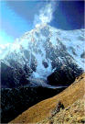

We are so fond of being out among Nature, because it has no opinions about us.

A New Prayer

The day's first thought.- The best way to begin a day well is to think, on awakening, whether we cannot give pleasure during the day to at least one person. If this could become a substitute for the religious habit of prayer our fellow-men would benefit by the change

Christianity
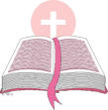
I call Christianity the one great curse, the one great intrinsic depravity, the one great instinct for revenge for which no expedient is sufficiently poisonous, secret, subterranean, petty -- I call it the one mortal blemish of mankind
In Christianity neither morality nor religion come into contact with reality at any point

Strength


What does not destroy me, makes me stronger.

Wisdom

Wisdom sets bounds even to knowledge.

Friendship and Marriage

The best friend will probably get the best wife, because a good marriage is based on talent for friendship

Stages of Life

Every philosophy is the philosophy of some stage of life. The stage of life at which a philosopher found his doctrine reverberates through it; he cannot prevent this, however far above time and hour he may feel.

Actors
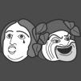

A great man? I always see only the actor of his own ideal.

Chance
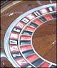

Those who deny chance.
-No victor believes in chance

Knowledge for its Own Sake
"Knowledge for its own sake,"—that is the ultimate snare which morality sets: with that one gets fully entangled once again in morality
The charm of knowledge would be slight, if there were not so much embarrassment to overcome on the route to knowledge

Dishonest to God

Man is most dishonest in relation to his god: he is not permitted to sin!

Love of God

Love of one man is a barbarity: for it is practiced at the expense of all the rest. Also the love for God.

The Hand that Kills

One has watched life badly if one has not also seen the hand which, in a considerate manner, kills.

Attaining the Ideal

Whoever attains his ideal, in act of doing just that goes beyond it

The Sexuality of Spirit

The degree and type of the sexuality of a man extend all the way to the ultimate peak of his spirit.

Principles

With their principles people want to tyrannize their habits or justify them or honour them or abuse them or hide them: two men with the same principles probably want them for fundamentally different things

Self-Hate

Anyone who despises himself nonetheless still respects himself as the one doing the despising
A soul which knows that it is loved but which does not love itself reveals its bottom layers—its deepest stuff comes up

Woman’s Hate

Woman learns to hate to the extent that she unlearns how to enchant

Men and Women
T
he same emotional affects in men and women have, nonetheless, a different tempo. That's the reason man and women do not cease misunderstanding each other.

Victims
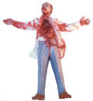

Dreadful experiences lead one to wonder whether the person who undergoes them is not something dreadful

Maturity

Maturity in a man: that means having found once again that seriousness which man had as a child, in play

Self-Deception
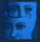
We all present ourselves to ourselves as more simple than we are: in this way we give ourselves a rest from our fellow human beings.

Criminals

The criminal is often enough not equal to his action: he diminishes and disparages it
The lawyers for a criminal are rarely sufficiently artistic to turn the beautiful terror of his action to the benefit of the person who did it.

The Observer

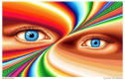

Anyone who feels himself predestined to observe and not to believe finds all those who believe too noisy and pushy: he keeps them at a distance.

Changes

The great epochs of our lives occur when we acquire the courage to rename our evil quality our best quality

Admiration

There is an innocence in admiration: such innocence belongs to the man who does not yet have any idea that he, too, could at some point be admired

Disgust

The disgust with filth can be so great that it prevents us from cleansing ourselves, from "justifying" ourselves.
When we have to change our minds about anyone, we hold the awkwardness which he has thus created for us against him.

Abstract Truth

The more abstract the truth you wish to teach, the more you must still seduce the senses to it.

The Devil

The devil has the widest perspective for God; that's why he keeps himself so far away from Him, for the devil is the oldest friend of knowledge.
Men are best punished for their virtues.

The Senses

All credibility, all good conscience, all appearance of the truth come only from the senses.

Artists and Scholars

By associating with scholars and artists one easily makes mistakes in reverse directions: behind a remarkable scholar we not infrequently find an average human being, and behind an average artists we often find a very remarkable human being.

Dreams

We act while awake as we do in a dream: we invent and fabricate the person with whom we associate—and then we immediately forget the fact.

Shit Happens

The lower abdomen is the reason man does not so easily consider himself a god.

Body and Soul

The most demure saying I have ever heard: "Dans le véritable amour c'est l'âme, qui enveloppe le corps." [In true love it's the soul which envelops the body]

Evil Age

What an age finds evil is commonly an anachronistic echo of what previously was found to be good—the atavism of an older ideal.

Becoming
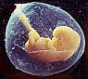

Around the hero everything becomes a tragedy, around the demi-god everything becomes a satyr play, and around a god every becomes—what? Perhaps a "world"?

The Tree of Knowledge
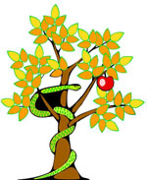

"Where the tree of knowledge stands is always paradise": that's what the oldest and the most recent serpents declare.

The Absolute
Objections, evasions, cheerful mistrust, and love of mockery are indications of health: everything absolute belongs with pathology.

Tragedy
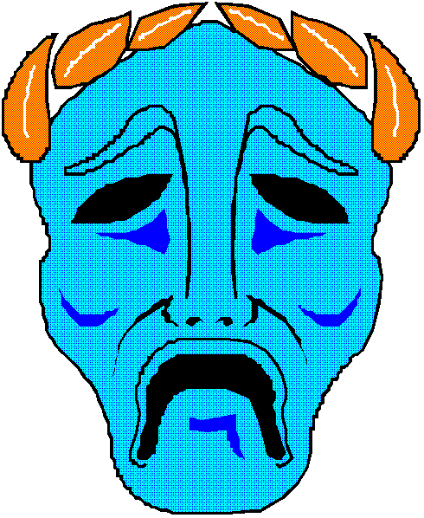

A sense of tragedy ebbs and flows with sensuality.

Suicide
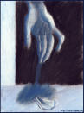

The thought of suicide is a strong consolation: with it people get through many an evil night.

The Tyrant in Us

Not only our reason but also our conscience submits to our strongest drive, the tyrant in us.

Love’s Eyes

Love brings to light the high and the hidden characteristics of the person who loves—what is rare and exceptional about him: to that extent it can mislead us about what is normal in him.

Intimacy
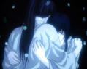

With hard people intimacy is a shameful thing—and something precious.

Eros
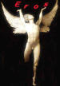

Christianity gave Eros poison to drink—but he didn't die from that. He degenerated into a vice.

Praise

In praise there is more pushiness than in blame

A man does not hate so long as he rates something low, but only when he rates something equal or higher.

Desire
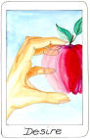

Ultimately one loves one's desires and not the objects one desires.

Vanity
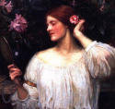

The vanity of others offends our taste only when it offends our vanity.

Lying

There is an innocence in lying which is the sign of good faith in something.
Not too deep.-- People who comprehend a thing to its very depths rarely stay faithful to it forever. For they have brought its depths into the light of day: and in the depths there is always much that is unpleasant to see.

Punishment
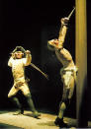
A strange thing, our kind of punishment! It does not cleanse the offender, it is no expiation: on the contrary, it defiles more than the offense itself.

Love-matches

Marriages contracted from love (so-called love-matches) have error for their father and need for their mother

Universal Love
Men have on the whole spoken of love with such emphasis and so idolized it because they have had little of it and have never been allowed to eat their fill of this food: thus it became for them 'food of the gods'.
Let a poet depict a utopia in which there obtains universal love, he will certainly have to describe a painful and ludicrous state of affairs the like of which the earth has never yet seen - everyone worshipped, encumbered and desired, not by one lover, as happens now, but by thousands, indeed by everyone else, as the result of an uncontrollable drive which would then be as greatly execrated and cursed as selfishness had been in former times; and the poets in that state of things - provided that they were left alone long enough to write - would dream of nothing but the happy, loveless past, of divine selfishness, of how it was once possible to be alone, undisturbed, unloved, hated, despised on earth, and whatever else may characterize the utter baseness of the dear animal world in which we live.The cure for love is still in most cases that ancient radical medicine: love in return
There is not enough love and goodness in the world for us to be permitted to give any of it away to imaginary things.

Convictions

Convictions are more dangerous enemies of truth than lies.

Words

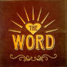

Every word is a prejudice
Why does man not see things? He is himself standing in the way: he conceals things

Mystical
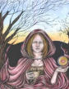

Mystical explanations are considered deep. The truth is that they are not even superficial

Truth
What then is truth? A mobile army of metaphors, metonyms, and anthropomorphisms -- in short, a sum of human relations, which have been enhanced, transposed, and embellished poetically and rhetorically, and which after long use seem firm, canonical, and obligatory to a people: truths are illusions about which one has forgotten that is what they are; metaphors which are worn out and without sensuous power; coins which have lost their pictures and now matter only as metal, no longer as coins.
We still do not know where the urge for truth comes from; for as yet we have heard only of the obligation imposed by society that it should exist: to be truthful means using the customary metaphors - in moral terms, the obligation to lie according to fixed convention, to lie herd-like in a style obligatory for all...

Fatal Truth

No one now dies of fatal truths: there are too many antidotes to them.
What are man's truths ultimately? Merely his irrefutable errors

Wagner
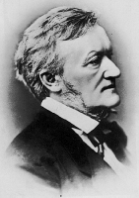
Never was there a greater master in dim, hieratic aromas - never was a man equally expert in all small infinities, all that trembles and is effusive, all the feminisms from the idiot icon of happiness! -

Lou Salome
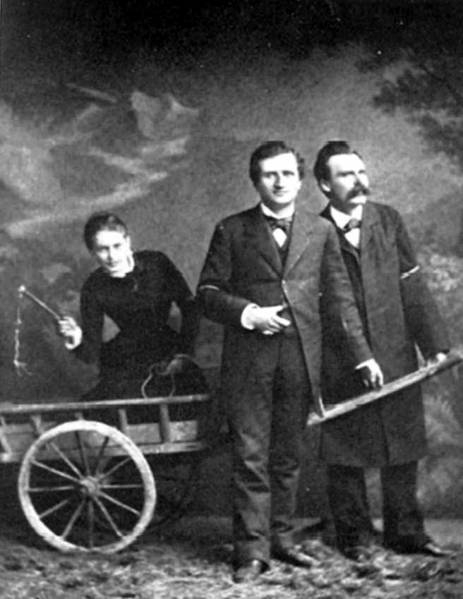
Nietzsche persistence in making photography of us three. Nietzsche in the heat of euphoria, not only insisted on doing it, but that took care, personally and with fervor, of the preparation of the details - like the small cart (that was too small),.

Elizabeth
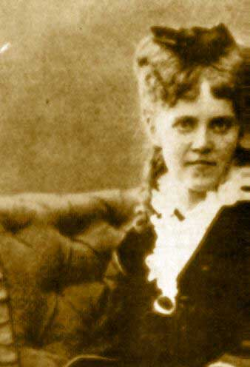
I confess that the deepest objection Against the "eternal return", that is my authentically abysmal thought, is always my mother and my sister.

Socrates

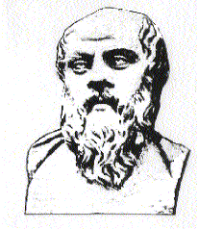

It was Socrates who invented the type of the philosopher: "theoretical man," one whose entire being is devoted to thought. Socrates said, as he died: "To live-that means to be sick a long time”

Suffering
Suffering has a meaning after all: it is the sufferer who brings it upon himself! The response is for the sufferer to turn against himself, to deny himself, to adopt ascetic ideals. "'I suffer: someone must be to blame for it' -- thus thinks every sickly sheep. But his shepherd, the ascetic priest, tells him: 'Quite so, my sheep! someone must be to blame for it: but you youself are this someone, you alone are to blame for
In this way, resentment is turned inward and the herd is rendered harmless. Self-punishment for one's own guilt is the most effective

Dionysis and Apollo
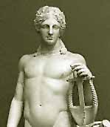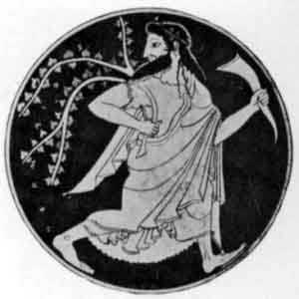

Will to Power
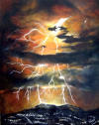
'From a psychological point of view the idea of cause is our feeling of power in the act of willing - our concept of effect is the superstition that this feeling of power is the force which moves things....
'If we translate the notion cause back into the only sphere which is known to us, and out of which we have taken it, we cannot imagine any change in which the will to power is not inherent. We do not know how to account for any change which is not a trespassing of one power on another'..

Ends and Means

He who has a why to live for can bear almost any how

Walking

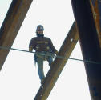

..The sedentary life is the very sin against the Holy Spirit. Only thoughts reached by walking have value.

Happiness

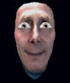

My formula for happiness: a Yes, a No, a straight line, a goal.

Morality

Morality is merely an interpretation of certain phenomena—more precisely, a misinterpretation

Fate
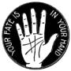

Such a spirit who has become free stands amid the cosmos with a joyous and trusting fatalism, in the faith that only the particular is loathsome, and that all is redeemed and affirmed in the whole—he does not negate anymore. Such a faith, however, is the highest of all possible faiths: I have baptized it with the name of Dionysus

Faith

A casual stroll through the lunatic asylum shows that faith does not prove anything.
"Faith" means not wanting to know what is true.

Reading
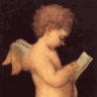

Early in the morning, when day breaks, when all is fresh, in the dawn of one's strength—to read a book at such a time is simply depraved!

Will to Power
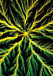

This world is the will to power—and nothing besides! And you yourselves are also this will to power—and nothing besides!

Nihilism

What does nihilism mean? That the highest values devaluate themselves. The aim is lacking; "why?" finds no answer.

Systems

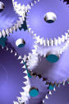

The will to a system: in a philosopher, morally speaking, a subtle corruption, a disease of the character; amorally speaking, his will to appear more stupid than he is—more stupid, that is to say: stronger, simpler, more imperious, more uneducated, more commanding, more tyrannical ...

I am not bigoted enough for a system—and not even for my system.

Heaven



In heaven all the interesting people are missing

Art

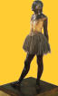

We possess art lest we perish of the truth

Eternal Return
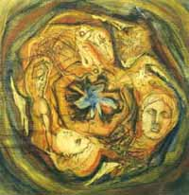
All things dance themselves: they come and hold out the hand and laugh and flee- and return. Everything goeth, everything returneth; eternally rolleth the wheel of existence. Everything dieth, everything blossometh forth again; eternally runneth on the year of existence. Everything breaketh, everything is integrated anew; eternally buildeth itself the same house of existence. All things separate, all things again greet one another; eternally true to itself remaineth the ring of existence.

Free Will and Fate

In freedom of the will, for the individual, resides the principle of separation . . . of absolute limitlessness. Fate, however, places Man back in the organic connection with the development of the whole and compels him . . . to the free development of the counter-action. Absolute, fateless freedom of will would make of Man a God, the fatalistic principle reduces him to an automaton.

